**DATA BASE (relation algebra)**

*201133216 정유석*

2.5 What is the result of first performing the cross product of student and advisor, and then performing a selection operation on the result with the predicate s_id = ID? (Using the symbolic notation of relational algebra, this query can be written as ~~~~)

-- (Frst)it is showing the list of all pairs of rows from the two input relations (student and advisor) (Second) that ID and s_id are same.

2.6 Consider the following expressions, which use the result of a relational algebra operation as the input to another operation. For each expression, explain in words what the expression does.

a. Netural join - student and takes of they years are greater or same than 2009

b. Show the students whose take is greater or same than 2009

c. Show the ID, name, course_id of (Netural join - student and takes)

2.7 Consider the relational database of Figure 2.14. Give an expression in the relational algebra to express each of the following queries:

a. Find the names of all employees who live in city “Miami”

b. Find the names of employees whose salary is greater than $100,000.

c. Find the names of all employees who live in “Miami” and whose salary is greater than $100,000.

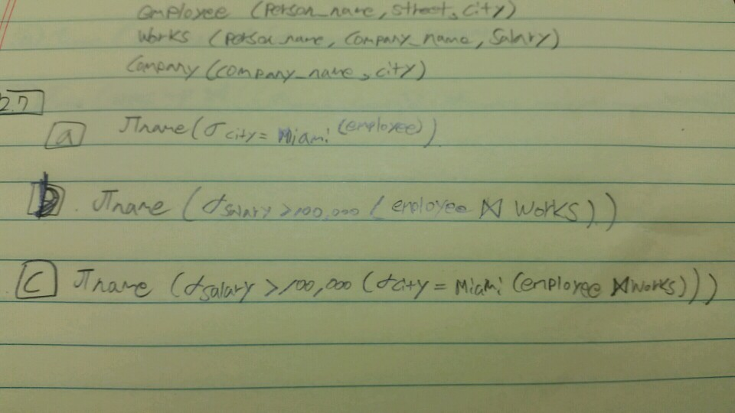

2.8 Consider the bank database of Figure 2.15. Give an expression in the relational algebra for each of the following queries.

a. Find the names of all branches located in “Chicago”.

b. Find the names of all borrowers who have a loan in branch “Down-town”.

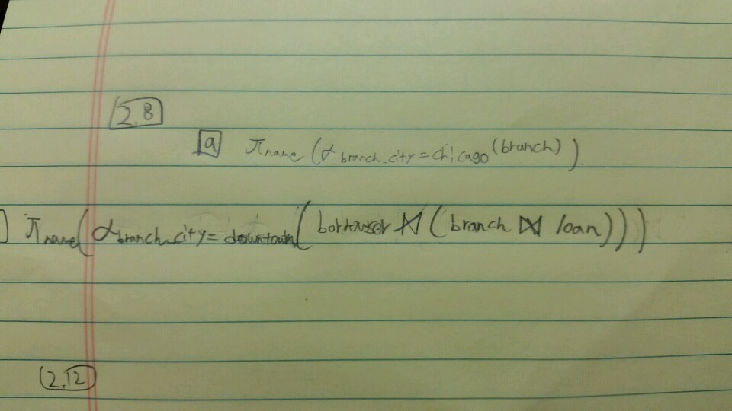

2.12 Consider the relational database of Figure 2.14. Give an expression in the relational algebra to express each of the following queries:

a. Find the names of all employees who work for “First Bank Corporation”.

b. Find the names and cities of residence of all employees who work for “First Bank Corporation”.

c. Find the names, street address, and cities of residence of all employees who work for “First Bank Corporation” and earn more than $10,000.

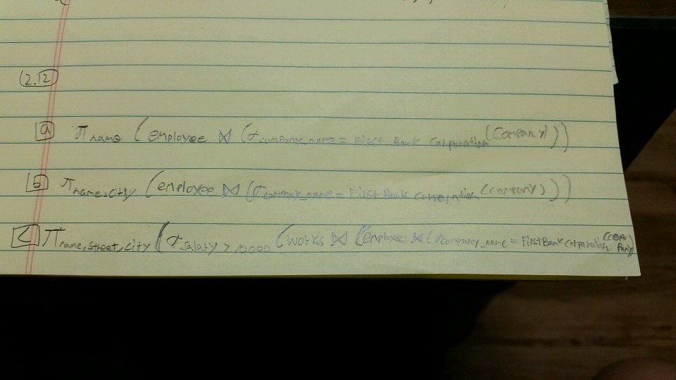

2.13 Consider the bank database of Figure 2.15. Give an expression in the relational algebra for each of the following queries:

a. Find all loan numbers with a loan value greater than $10,000.

b. Find the names of all depositors who have an account with a value greater than $6,000.

c. Find the names of all depositors who have an account with a value greater than $6,000 at the “Uptown”branch.

